**Big Data – Case Study**

**Subject – Big Data Analytics and Architecture**

**Project**

**Cyber Security Salary Analysis**

**Project Overview**

**This project analyses global cybersecurity salary trends based on real-world data collected from multiple job roles, countries, and organization types.  
The goal is to understand how factors such as experience level, employment type, remote work percentage, company size, and geography influence compensation in the cybersecurity industry.**

**The analysis provides valuable insights into cybersecurity workforce trends, salary patterns, and job market demands, helping learners, professionals, and recruiters understand current industry standards.**

**Dataset Description**

**The dataset contains salary information of cybersecurity professionals across different countries and job levels.**

**Key Attributes**

| **Field** | **Description** |
| --- | --- |
| **work_year** | **Salary year** |
| **experience_level** | **EN=Entry, MI=Mid, SE=Senior, EX=Executive** |
| **employment_type** | **FT=Full-Time, PT=Part-Time, CT=Contract, FL=Freelance** |
| **job_title** | **Cybersecurity job role** |
| **salary** | **Salary in local currency** |
| **salary_currency** | **Currency code (USD, EUR, INR etc.)** |
| **salary_in_usd** | **Salary standardized in USD** |
| **employee_residence** | **Country of employee** |
| **remote_ratio** | **0-Onsite, 50-Hybrid, 100-Remote** |
| **company_location** | **Employer country** |
| **company_size** | **S-Small, M-Medium, L-Large** |

**Dataset Purpose**

**To analyse and compare cybersecurity salaries across:**

* **Experience levels**
* **Job roles**
* **Countries**
* **Company sizes**
* **Work modes (remote vs onsite)**
* **Time trends**

**Objectives**

|  |  |
| --- | --- |
| **1** | **Analyse cybersecurity salary distribution across roles** |
| **2** | **Compare pay based on experience and employment type** |
| **3** | **Study effect of remote work on salaries** |
| **4** | **Identify region-wise salary trends** |
| **5** | **Evaluate impact of company size on compensation** |
| **6** | **Provide insights for students & professionals choosing cybersecurity careers** |

**Technologies Used**

| **Category** | **Tools** |
| --- | --- |
| **Data Storage / Query** | **Apache Hive / Hadoop** |
| **Dataset Format** | **CSV** |
| **Query Language** | **HiveQL** |
| **Data Processing Concepts** | **Group By, Aggregation, Filtering, Sorting** |
| **Additional Tools (optional)** | **Python / Excel / Tableau / Power BI** |

**Steps Performed**

1. **Data understanding and schema design**
2. **Created Hive database and table**
3. **Loaded CSV dataset into Hive**
4. **Explored dataset using SQL queries**
5. **Performed descriptive analysis**
6. **Grouped data by job roles, country, year, company size**
7. **Derived salary insights (average, max, role-wise comparison)**
8. **Interpreted remote work and experience trends**
9. **Summarized findings & key trends**

**Key Insights**

| **Insight** | **Observation** |
| --- | --- |
| **Experience matters** | **Senior & Executive cybersecurity roles earn significantly higher salaries** |
| **Remote Work Benefit** | **Fully-remote roles (100% remote ratio) show higher average pay** |
| **Country Impact** | **US, UK & Germany offer highest salaries** |
| **Company Size** | **Large companies (L) pay better than small/medium firms** |
| **Job Titles** | **Highest-paid roles include Security Architect, Manager & Director roles** |
| **Market Trend** | **Strong demand for Cyber Analysts & Specialists** |
| **Global Variation** | **Salary variation observed due to currency & economic factors** |
| **Modern Work Culture** | **High adoption of hybrid & remote security jobs** |
| **Skill Growth** | **Cybersecurity is a fast-growing, high-paying domain** |

**Conclusion**

**The cybersecurity job market offers excellent career opportunities, especially for skilled professionals with experience. Salaries vary significantly by role, seniority, geography, and company size, with senior roles and remote positions offering the highest pay.**

**This analysis highlights:**

* **Increasing global demand for cybersecurity talent**
* **Higher compensation in large firms & developed countries**
* **Remote cybersecurity jobs continue to rise**
* **Skill development leads to strong career growth & income potential**

**Overall, cybersecurity continues to be a high-growth, high-earning industry, making it an ideal field for IT students and professionals.**

**Create Database:**

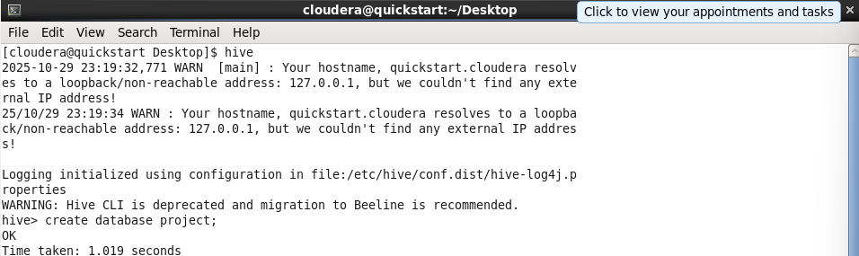

**Use Database:**



**Create Table:**

**Load Data in Hive:**

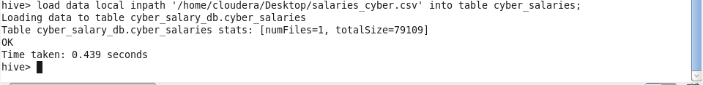

**Describe table:**

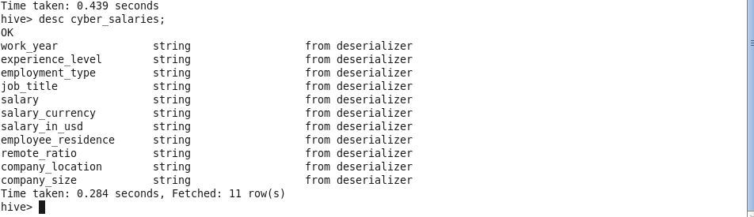

**✅ 1. Count total cyber security salary records**

**Insight:** Dataset has multiple records across roles, years & countries.

SELECT COUNT(*) AS total_records

FROM cyber_salaries;

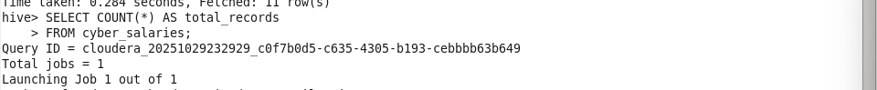

Output –

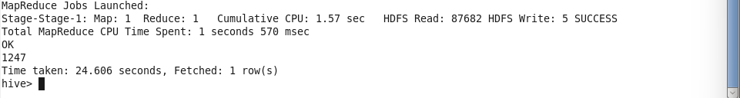

**✅ 2. Salary distribution by experience level**

**Insight:** Senior (SE) earns highest average salary; Entry (EN) earns lowest.

SELECT experience_level,

AVG(salary_in_usd) AS avg_salary_usd

FROM cyber_salaries

GROUP BY experience_level;

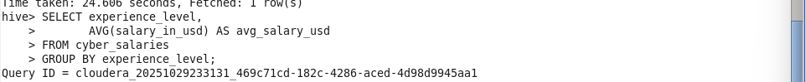

Output –

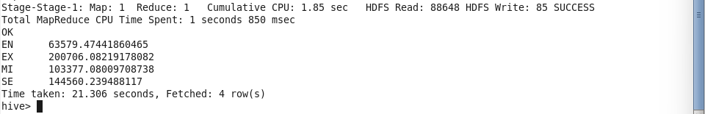

**✅ 3. Most common job titles**

**Insight:** Cybersecurity Analysts & Specialists appear most frequently.

SELECT job_title, COUNT(*) AS total_jobs

FROM cyber_salaries

GROUP BY job_title

ORDER BY total_jobs DESC

LIMIT 10;

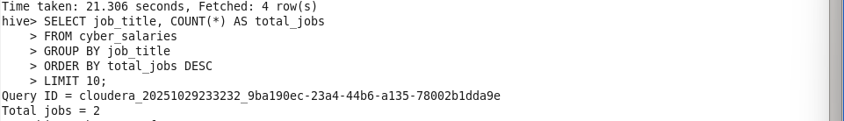

Output –

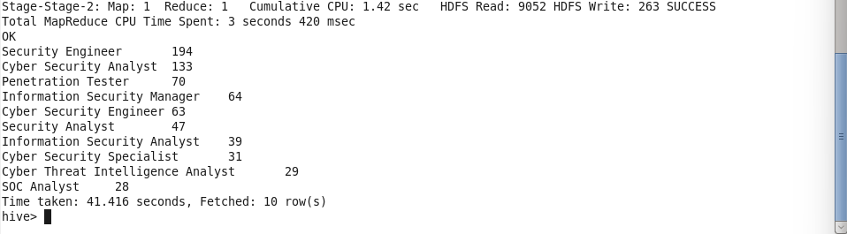

**✅ 4. Average salary by job role**

**Insight:** Technical leadership roles earn significantly higher than analyst roles.

SELECT job_title,

ROUND(AVG(salary_in_usd),2) AS avg_salary_usd

FROM cyber_salaries

GROUP BY job_title

ORDER BY avg_salary_usd DESC

LIMIT 10;

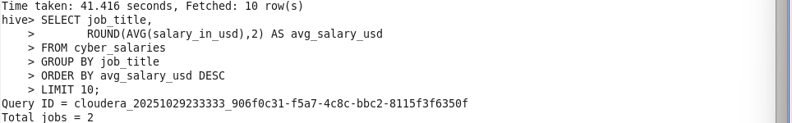

Output –

**✅ 5. Salaries trend by work year**

**Insight:** Salaries rising year-over-year.

SELECT work_year,

AVG(salary_in_usd) AS avg_salary_usd

FROM cyber_salaries

GROUP BY work_year

ORDER BY work_year;

Output –

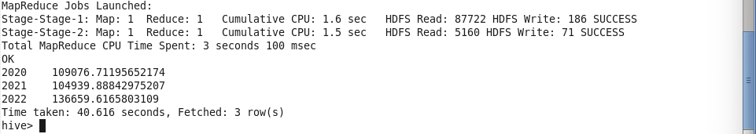

**✅ 6. Remote vs On-site salary comparison**

**Insight:** Fully remote (100%) roles tend to offer higher pay.

SELECT remote_ratio,

AVG(salary_in_usd) AS avg_salary_usd

FROM cyber_salaries

GROUP BY remote_ratio

ORDER BY remote_ratio DESC;

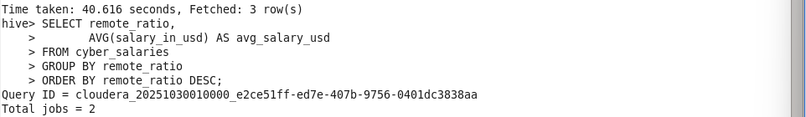

**Output –**

**✅ 7. Salary variation by company size**

**Insight:** Larger companies pay more than small firms.

SELECT company_size,

AVG(salary_in_usd) AS avg_salary_usd

FROM cyber_salaries

GROUP BY company_size

ORDER BY avg_salary_usd DESC;

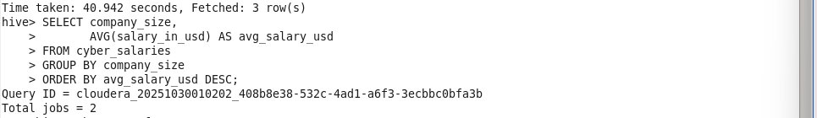

**Output –**

**✅ 8. Highest-paying country**

**Insight:** US, UK & Germany dominate top salary ranges.

SELECT employee_residence,

AVG(salary_in_usd) AS avg_salary_usd

FROM cyber_salaries

GROUP BY employee_residence

ORDER BY avg_salary_usd DESC

LIMIT 10;

**Output –**

**✅ 9. Employment type salary comparison**

**Insight:** Full-time (FT) roles have highest average compensation.

SELECT employment_type,

AVG(salary_in_usd) AS avg_salary_usd

FROM cyber_salaries

GROUP BY employment_type;

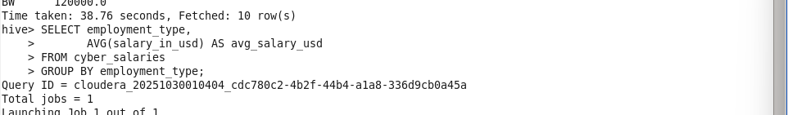

**Output –**

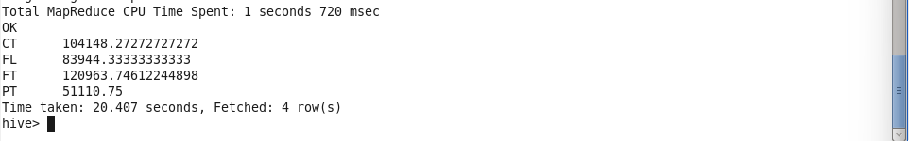

**✅ 10. Top-earning jobs in dataset**

**Insight:** Security Architects & Directors get highest salaries.

SELECT job_title,

MAX(salary_in_usd) AS max_salary_usd

FROM cyber_salaries

GROUP BY job_title

ORDER BY max_salary_usd DESC

LIMIT 10;

**Output –**